Activity 1
Ryan Coon
SDD-630
Professor Munirah Alrashed
October 7, 2026

In today’s world, environmental awareness and sustainability have become critical concerns for individuals and communities alike. Despite growing interest in reducing carbon footprints and adopting eco-friendly habits, many people struggle to understand their personal impact on the environment and how their daily choices contribute to larger ecological outcomes. To address this gap, I propose a mobile application called EcoTrack, designed to help users monitor, understand, and reduce their environmental footprint through personalized tracking, education, and community engagement. The following outlines the concept of EcoTrack, describes the ideal user profile, and identifies the main features that make this app a valuable tool for promoting sustainable living.
Concept and Purpose of EcoTrack
EcoTrack is a mobile application that empowers users to track their environmental impact in real time by logging daily activities related to energy consumption, transportation, waste generation, and consumption habits. The app’s primary goal is to raise awareness about individual contributions to climate change and resource depletion while providing actionable insights and incentives to encourage sustainable behavior. Unlike generic carbon calculators, EcoTrack integrates multiple data sources, including smart home devices, GPS tracking, and user input, to offer a comprehensive and personalized environmental profile. The app also fosters a community of environmentally conscious users who can share tips, challenges, and achievements, creating a supportive ecosystem that motivates continuous improvement. By combining data-driven insights with social engagement and gamification, EcoTrack aims to make sustainability accessible, measurable, and rewarding for everyday users.
Ideal User Profile
The ideal user of EcoTrack is a socially and environmentally conscious individual who is motivated to reduce their ecological footprint but may lack the tools or knowledge to do so effectively. This user is typically between 18 and 45 years old, tech-savvy, and interested in sustainability, climate change, and personal wellness. They may be students, young professionals, or families who want to make informed decisions about their lifestyle choices, such as reducing energy consumption, minimizing waste, or choosing greener transportation options.
This user values data and feedback, appreciates personalized recommendations, and enjoys participating in community-driven initiatives. They are likely to be active on social media and responsive to gamified experiences that reward positive behavior. Additionally, EcoTrack can appeal to organizations and educational institutions seeking to promote environmental responsibility among their members by providing group challenges and reporting tools.
Main Features of EcoTrack
Comprehensive Environmental Impact Tracking
EcoTrack’s core feature is its ability to track various aspects of a user’s environmental footprint. Users can manually log activities such as electricity and water usage, waste disposal, recycling habits, and transportation modes such as walking, biking, driving, and public transit. The app also integrates with smart home devices and utility providers to automatically import energy consumption data, providing accurate and up-to-date information. GPS tracking helps estimate emissions from travel, while barcode scanning allows users to assess the environmental impact of purchased products based on their lifecycle data.
Personalized Insights and Recommendations
Based on the collected data, EcoTrack generates a personalized environmental profile that highlights the user’s biggest impact areas and offers tailored recommendations to reduce their footprint. For example, if a user’s transportation emissions are high, the app might suggest carpooling, biking, or using public transit more frequently. If energy consumption is excessive, EcoTrack could recommend energy-efficient appliances or behavioral changes like turning off lights when not in use. These insights are presented through easy-to-understand visuals and progress reports, helping users set realistic goals and track improvements over time.
Gamification and Rewards System
To encourage sustained engagement, EcoTrack incorporates gamification elements such as badges, points, and leaderboards. Users earn rewards for completing eco-friendly actions, participating in challenges, and achieving milestones. The app partners with eco-conscious brands and local businesses offer discounts, coupons, or donations to environmental causes as incentives. This system not only motivates users but also builds a sense of accomplishment and community recognition.
Community Engagement and Social Sharing

EcoTrack includes a social platform where users can join groups, share tips, post achievements, and participate in community challenges. This feature fosters peer support and friendly competition, which research shows can significantly enhance behavior change. Users can follow friends, join local or global sustainability campaigns, and contribute to collective goals such as reducing plastic waste or planting trees. Integration with popular social media platforms allows users to share their progress and inspire others.
Educational Content and News Feed
To complement tracking and engagement, EcoTrack offers curated educational content, including articles, videos, and podcasts on environmental topics. The app’s news feed keeps users informed about the latest developments in climate science, policy changes, and innovative green technologies. This feature helps users stay motivated and deepen their understanding of sustainability issues.
Customizable Notifications and Reminders
EcoTrack provides customizable notifications to remind users of daily eco-friendly actions, upcoming challenges, or milestones. These reminders are designed to be encouraging rather than intrusive, helping users build sustainable habits gradually. For example, the app might prompt users to bring reusable bags when shopping or remind them to recycle properly.
Data Privacy and Security
Recognizing the sensitivity of personal data, EcoTrack prioritizes user privacy and security. All data is encrypted, and users have full control over what information is shared within the community or with third parties. Transparency about data usage builds trust and encourages more accurate logging.
Why EcoTrack is a Valuable Addition to the Market
EcoTrack addresses a growing demand for tools that help individuals take meaningful action against climate change. While many apps focus on fitness, finance, or social networking, few provide a holistic and personalized approach to environmental impact tracking. By integrating multiple data sources and combining tracking with education and social engagement, EcoTrack offers a unique value proposition.
Moreover, the app’s gamification and rewards system taps into behavioral psychology principles, making sustainability enjoyable and socially rewarding. This approach increases the likelihood of long-term behavior change, which is essential for addressing environmental challenges. EcoTrack’s community features also leverage social influence, a powerful motivator for adopting new habits.
EcoTrack is an innovative mobile application designed to empower users to understand and reduce their environmental footprint through comprehensive tracking, personalized insights, gamification, and community engagement. Its ideal users are environmentally conscious individuals seeking practical tools and motivation to live more sustainably. By combining data-driven feedback with social support and educational content, EcoTrack not only helps users make informed choices but also fosters a global community committed to positive environmental impact. As awareness of climate change grows, applications like EcoTrack will play a crucial role in translating concern into action, making sustainability accessible and rewarding for everyone.

Solution Design
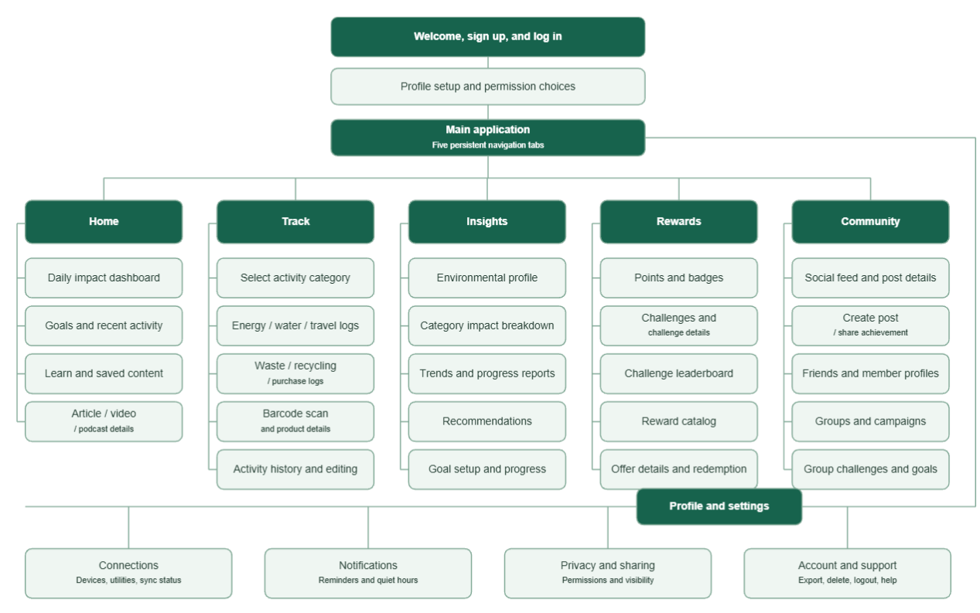

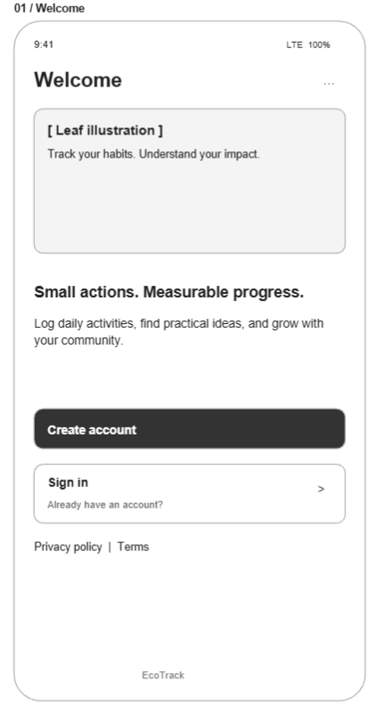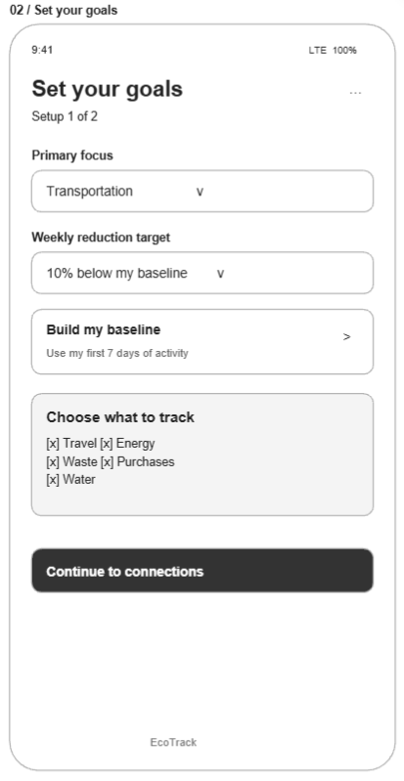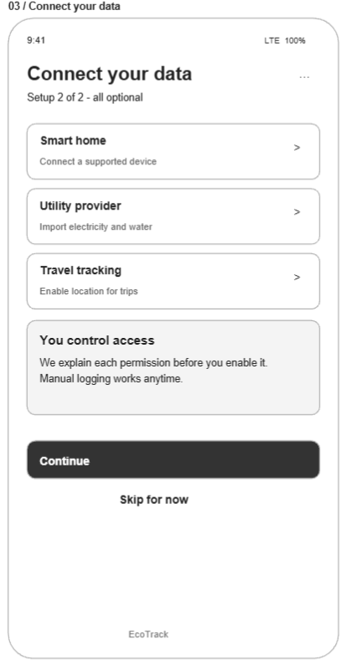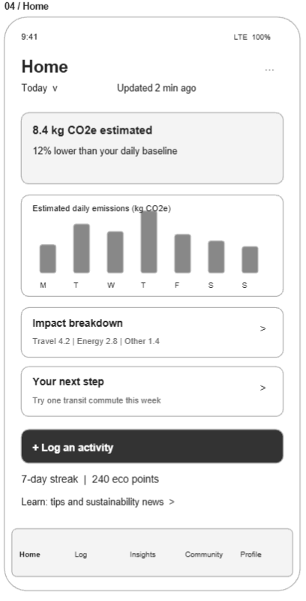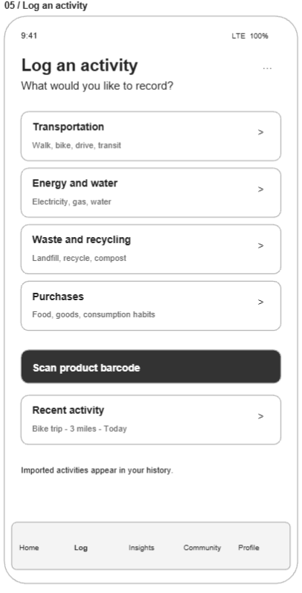
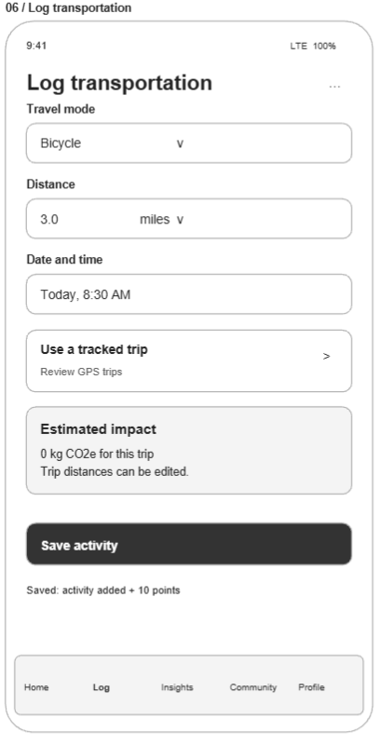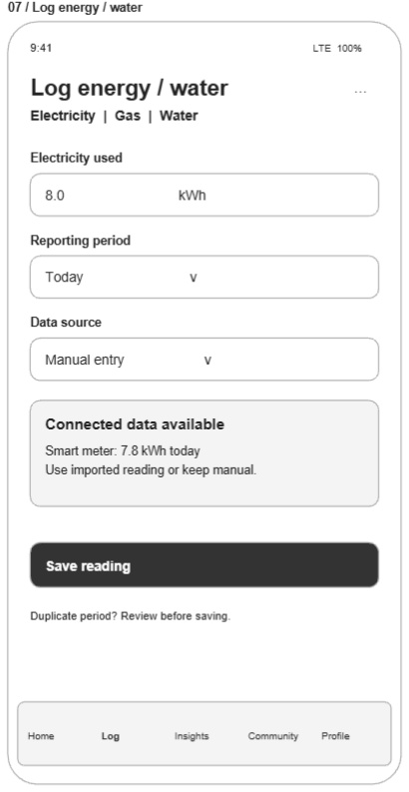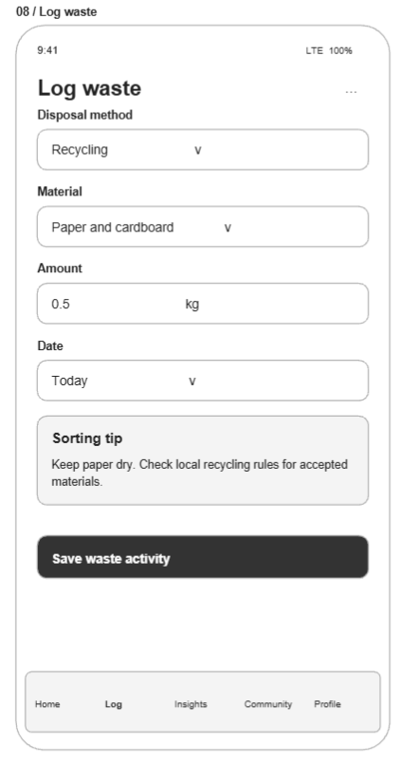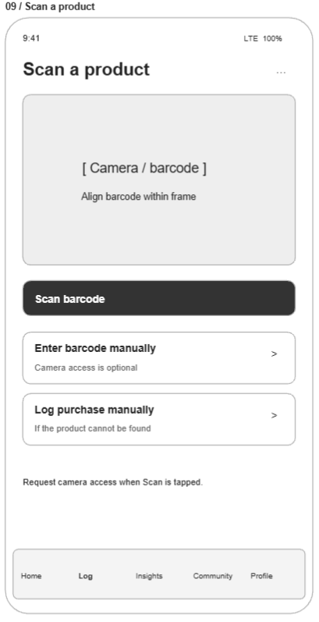
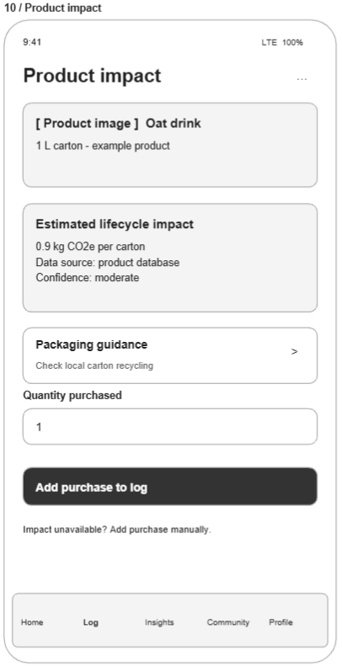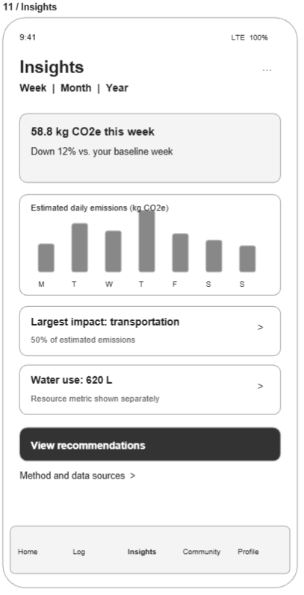

References
Briskman, J. (2026, January 21). 2026 State of mobile: AI moves mobile into its next phase. Sensor Tower. Sensortower.Com. https://sensortower.com/blog/state-of-mobile-2026
Deloitte. (2024, November 26). Mobile experiences: Enhancing user engagement and business growth. Deloitte. Deloitte Insights. https://www.deloittedigital.com/us/en/insights/perspective/mobile-app-best-practices.html
Dickey, M. R., & Shontell, A. (2013, February 12). The Silicon Valley 100. Business Insider. https://www.businessinsider.com/the-silicon-valley-100-2013-2
Howerton, A. (2020). Legal retaliation to innovation: How existing industries greet new technological developments with litigation and hinder industry success in the process. Southern California Interdisciplinary Law Journal, 29(515). https://gould.usc.edu/why/students/orgs/ilj/assets/docs/29-3-Howerton.pdf
Maha. (2025, February 9). How mobile apps improve customer loyalty. Addicta. https://addictaco.com/how-mobile-apps-improve-customer-loyalty/

